**Accessibility Guide for Clifton Park Museum** cliftonparkmuseum@rotherham.gov.uk, 01709 336633, www.cliftonpark.org.uk

**Contact for accessibility enquiries: Wendy Foster**

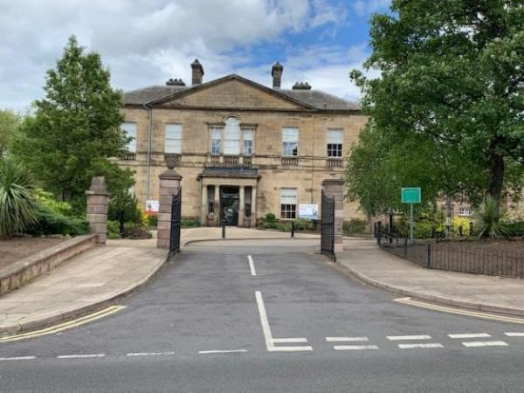

# Welcome

Clifton House, built in 1783, and it's grounds were formerly the property of the Walker family who ran the Rotherham Ironworks. Known today as Clifton Park Museum it offers an exciting experience for all to enjoy.

The Museum not only tells the fascinating history of the Rotherham Borough it also houses the York & Lancaster Regimental Museum and the Archives & Local Studies searchroom.

Throughout the Museum you will find plenty to keep the younger ones entertained with a wide range of interactives. Don't forget to visit the much-loved Nelson the Lion.

# At a Glance

## Level Access

• There is level access from the three entrances to:

* Reception areas
* Cafe
* Lion's Den, under 5's area
* Gift shop
* Unisex accessible toilet
* Male and Female toilets
* Changing Places
* Ground floor galleries
* Archives & Local Studies searchroom
* Lift to upper floor
* The main park

## Hearing

* We have a hearing loop in The Gift Shop and in Archives & Local Studies.
* Some staff have disability awareness training

## Visual

* Glass doors have contrast markings.
* The walls and the doors have high colour contrast
* Some parts of the venue have low lighting

## General

* There is at least 1 public toilet for disabled visitors
* Some staff have disability awareness training

# Getting here

Clifton Park Museum

Clifton Lane

Rotherham

S65 2AA

## Travel by Public Transport

* You can get to Clifton Park Museum by bus, train and tram
* The nearest bus stop is directly outside the Museum. If travelling from the Bus Station you need to catch the number X1. The bus stop is 0.0 miles / 0.0 km from Clifton Park Museum
* The nearest train station is Rotherham Railway Station. The train station is 0.8 miles / 1.3 km from Clifton Park Museum
* The nearest tram station is Rotherham Railway Station. The tram station is 0.8 miles / 1.3 km from Clifton Park Museum
* Taxis are available from the station or you could walk to the Museum Should you choose to walk you will go up a moderate incline for the majority of the journey ***Travel by Taxi***
* You can get a taxi with A1 Taxis by calling 01709 555555. The taxi company has a wheelchair accessible vehicle

## Travel by Car - Parking

* There is a car park with accessible parking spaces. The parking is less than 50 metres from the main entrance
* Although no designated drop off point, you can pull up outside the main entrance or near the shop entrance
* The car park is pay and display, you can pay by cash, card, app or over the telephone. For Blue badge holders parking is free in any designated bay as long as the Blue badge is displayed. There are 143 parking spaces with an additional 5 designated accessible parking bays. From the car park to the entrance, there is level access. The path is sloped
* The route is 1200mm wide, or more
* The nearest Blue badge parking space is 41 metres away from the main entrance and 16.5 metres away from the shop entrance.

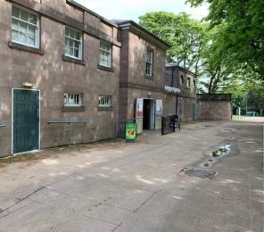

Image shows shop entrance from nearest Blue Badge bays

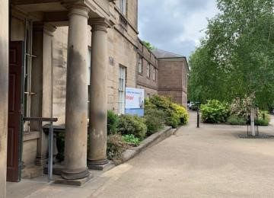

Image shows front entrance towards nearest Blue Badge bays **Arrival**

## Path to Main Entrance

* From the street to the main entrance, there is level access
* The path is 1800mm wide, or more
* The path is sloped

## Main Entrance

* The main entrance has level access
* The door is 1050mm wide
* The main door is side hung and automatic
* The main entrance doors automatically open inwards as you approach
* Staff will be present to greet you on your arrival

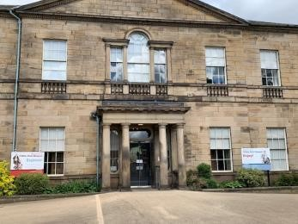

Image shows front entrance showing the slope and glass doors, these doors automatically open inwards

# Getting around inside

## Visual Impairment - General Information

* We have contrast markings on all glass doors and high colour contrast between walls and doorframes
* Some parts of the venue have low lighting

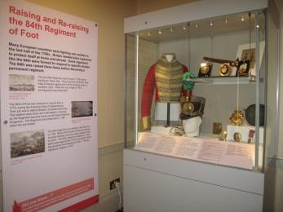

Image shows sample contrast between, panels, wall, and case.

## Lift

* We have 1 lift
* You can get a lift to all floor • The lift door is 900mm wide
* The lift is 900mm wide.
* The lift is 1500mm deep
* The lift says the floor number at each floor
* The lift buttons have raised numbers or letters
* The lift shows the floor number, at each floor
* The lift goes between ground level and the first floor, all buttons have Braille on them

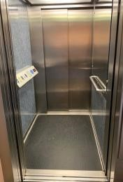

Image shows inside the lift

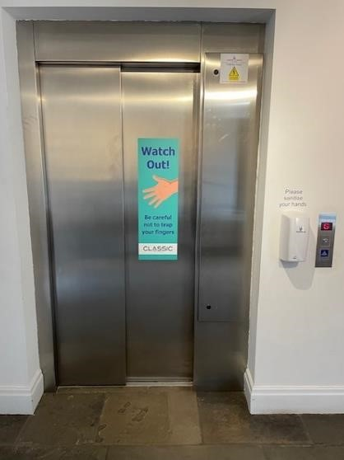

Image shows outside the lift

## Main entrance

* Staff are present in the main entrance
* There is level access to all ground floor galleries
* This is the way into the museum to visit the galleries

## Gift shop reception desk

* The desk is situated within the gift shop and can be accessed directly from the outside by level access or from inside the museum or cafe. All access routes are level, there are automatic double width sliding doors from the outside and manual single wooden doors which can turn into double from the museum or single door from the cafe.

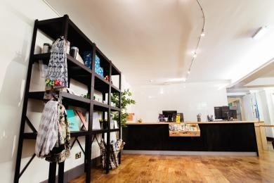

Image shows shop counter and display

*Lion's Den, under 5's area*

* From the main entrance to this area, there is level access. The route is 940mm wide, or more. The door is 940mm wide
* Some display information is low, for wheelchair users. There are seats.
* This area is small, some of the accessories can be moved to give more space when needed. Nelson the Lion is one of the much loved exhibits that visitors want to see

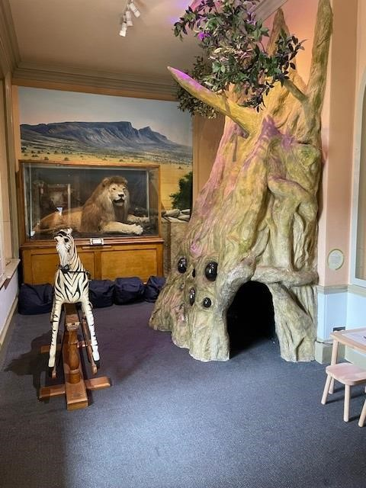

Image shows Lion's Den.

## Public toilet

* **Unisex accessible toilet.** 
  + There is a public toilet for disabled visitors
  + You need a RADAR key to open the public toilet
  + From the main entrance to the public toilet, there is level access. There is a permanent ramp
  + The route is 900mm wide, or more
  + The toilet door is 900mm wide
  + The direction of transfer onto the toilet is to the right
  + There is 1100mm at the side of the toilet. There is 1300mm in front of the toilet. The toilet seat is 460mm high. The toilets have handrails
  + The accessible toilet is through an outward facing single light door with a twist lock. The toilet is 215cm x 188cm in size. The sink is fixed height and the toilet roll holder is on the left hand side at a height of 123cm. There is a colour contrast between the walls and critical surfaces, the utilities are white. The floor is non slip. Wall mounted and drop rails are available on either side of the toilet.
  + Within the Park there is an accessible toilet with a hoist, to access this you would need to contact the Parks department prior to your visit and they will be able to arrange this. Please either email Clifton@rotherham.gov.uk or telephone 01709 254588.

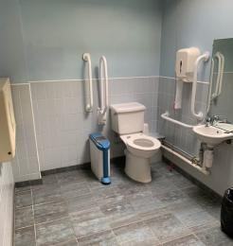

Image shows inside the accessible toilet

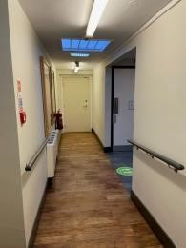

Image shows corridor lea*ding to toilet area.*

* **Male and Female toilets** 
  + Next to the unisex accessible toilet there are also male and female toilets which do not require a key to unlock. The male toilet contains 1 cubicle and urinals as well as a baby changing unit. There are sinks and 2 hand dryers.
  + The female toilets contain 4 cubicles, 1 with handrails and an outward facing door. There are 3 standard height sinks and 1 low level sink as well as 2 hand dryers and a baby changing unit.

* **Changing Places** 
  + There is a registered Changing Places facility on the ground floor at the end of the Early Rotherham gallery, this can be accessed with a radar key. [Click here](https://www.changing-places.org/) for more information about Changing Places facilities.

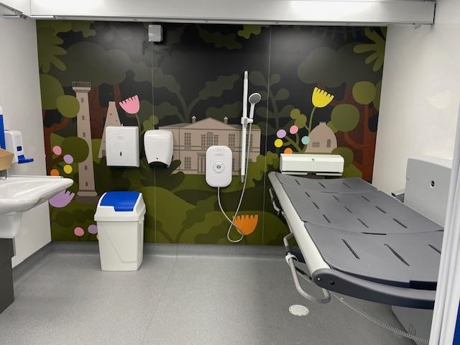

Image shows inside of Changing Places facility

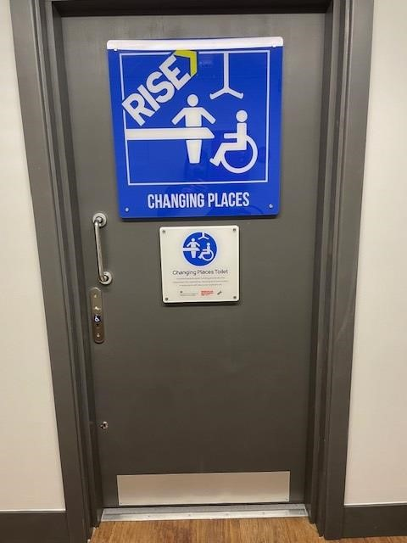

Image shows exterior of Changing Places facility

***Shop***

## Gift Shop

* From the main entrance to the shop, there is level access. The route is 880mm wide, or more. The door is 1900mm wide.
* The route through the shop is 800mm wide, or more.
* The gift shop and can be accessed directly from the outside by level access or from inside the museum or cafe. All access routes are level, there are automatic sliding doors from the outside and manual wooden doors from the museum or cafe. There is a a reception desk with a low level counter and a hearing loop system which staff are trained to use. The products are displayed primarily on open shelving at a variety of heights; retrieval of items from the highest shelves may require assistance for wheelchair users.

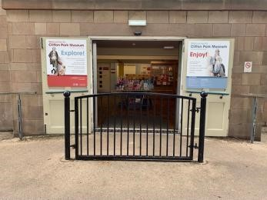

Image shows gift shop entrance.



Image shows shop counter and area

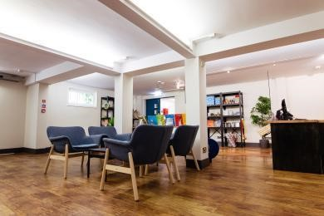

Images shows shop area and floor

***Place to eat and drink***

## The Walker Cafe

* From the main entrance to the dining area, there is level access. The route is 900mm wide, or more. The door is 900mm wide.
* To get to a table, there are no steps.
* The dining area is self-service. If you need table service, staff can help you.
* The route through the dining area is 800mm wide, or more.
* There is no background music.
* The table and plates have high colour contrast.
* We cater for vegetarian diets plus a limited amount of vegan and gluten free.
* The menu includes a selection of freshly made sandwiches, warm flatbreads, freshly made soup and a selection of cakes and freshly made flapjack and scones. With prior notice we will try to accomodate specific catering needs.

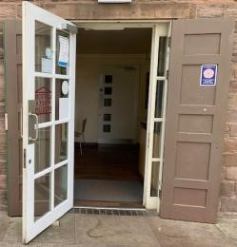

Image shows exterior cafe door

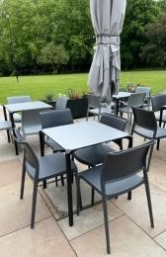

Image shows exterior cafe furniture

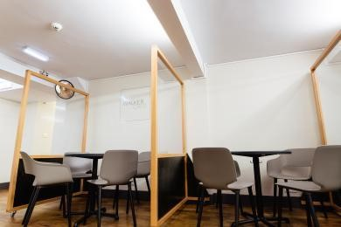

Image shows cafe seating

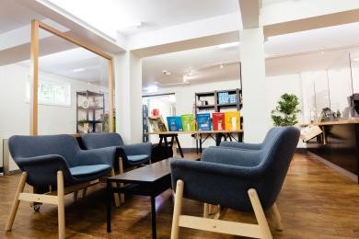

Image shows shop area and floor

### Archives & Local Studies searchroom

* From the main entrance to this area, there is level access. The route is 900mm wide, or more.
* The door is 880mm wide.
* The searchroom is accessed via the Gift shop through an outward facing manual door. There is ample room for wheelchair users, staff members are available to assist where needed and with any queries. Magnifying glasses are available if required. There is a portable hearing loop on the reception desk. Tables for researchers are height adjustable, chairs used by researchers are fixed height, chairs used at the computer tables are swivel and adjustable height.

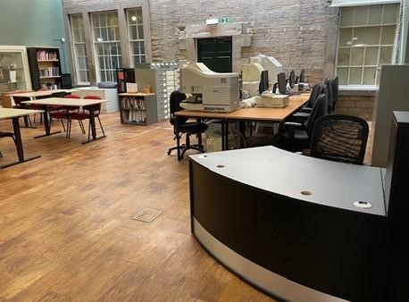

Image shows the searchroom from the entrance

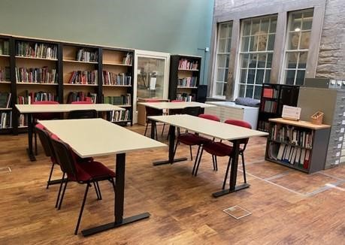

Image shows the searchroom looking towards the research table

# Getting around outside

## The main park

* From the main entrance to the gardens, there is level access.
* The Museum is situated within a public park, access to the park is free at all times. There are various areas within the park including open grassland, formal gardens,play areas,skate park and basketball court which are free and always open. There are other areas which have either specific opening times or may be chargeable, these include the water play, fun fair amusements, bowling, tennis and crazy golf.

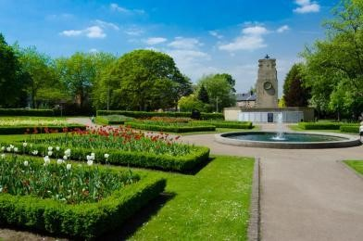

Image shows memorial garden

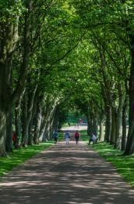

Image shows footpath from the Museum towards the main park area

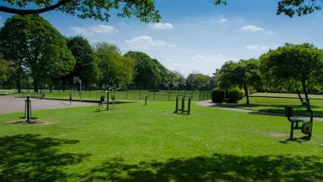

Image shows exercise equipment within the park

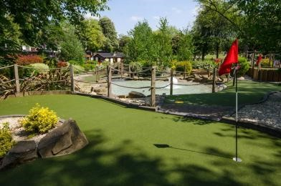

Image shows crazy golf course

## Customer care support

### Accessibility equipment

* A wheelchair is available for use inside the museum free of charge
* We have a hearing loop in The Gift Shop and in Archives & Local Studies.
* Magnifying glasses are available within the galleries and can be provided on request in Archives & Local Studies.
* Mobility scooters can be hired for free from the Garden building for a refundable deposit. The Garden building is situated near to the Museum building. These must be pre-booked.
* There is plenty of open grassland directly outside the museum, there are dog waste bins located around the park. A water bowl is also available outside the Walker Cafe.
* Although we do not have a designated space, if you speak to a member of staff in the museum they will find you a suitable place where you can charge your scooter or chair.
* You can hire mobility equipment from Parkgate Mobility by calling 0800 7720 744.

### Emergency evacuation procedures

* We have emergency evacuation procedures for disabled visitors.
* Flashing lights are in the accessible toilet, Changing Place and the shop area only. Staff are situated throughout the building and will assist with the evacuation should the fire alarm be activated. All public areas are checked by staff to ensure everyone is out safely.

### Customer care support

* Some staff have disability awareness training.
* One member of staff has recently completed the Accessbility Champion Train the Trainer programme accredited through Access for All UK, and the majority of staff have undertaken the Accessbility training course. Some members of staff have completed stage 1 Makaton.

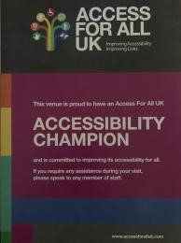

Image of Access for All UK Certificate.

* We have other services for people with accessibility requirements.
* With prior notice, tours can be provided for groups. Staff on duty will also provide assistance where needed to ensure the visitor gets the best out of their visit.

## Guide last updated: 2nd July 2024